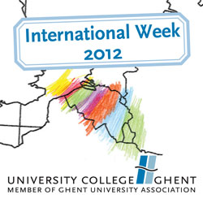

University College Ghent
Faculty of Life Sciences and Technology
International Week: 19th – 23rd of March 2012
Expression of interest

Please send this form at the latest by 20/1/2012 to: Inez.adriaensen@hogent.be

Name and surname:
Your home institution:
City and country:

Your position:
Telephone:

E-mail:

I will attend the International Week from Monday 19 till Wednesday 21 March ‘12 and I’m interested in giving a lecture on this/these topic(s):
……………………. ……………..
Further details (if possible):
My lecture is suitable for: a small group only: persons
a large group
group size is not important
For my lecture I will need: laptop
beamer
other:
I will lecture in: English
French
German
I’m a international relations officer and I want to visit the Faculty of Life Sciences and Technology from Monday 19 till Wednesday 21 March ’12.
I will not attend the International Week of University College Ghent.

If you would like to participate in the international staff training offered by the Central International Relations Office on Thursday 22 and Friday 23 March ‘12, please contact internationalweek@hogent.be

